
SHHH! Self-Help for Hard-of-Hearing
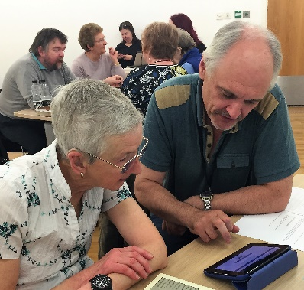
This is a FREE support group which runs on the first Tuesday of every month at Newcastle Central Library. We aim to provide members with a range of interesting topics that link to hearing loss or opportunities that are accessible to people with a hearing loss.
The group is informal and offers members an opportunity to discuss shared experiences. It is also the forum where accessibility issues are discussed and challenged.
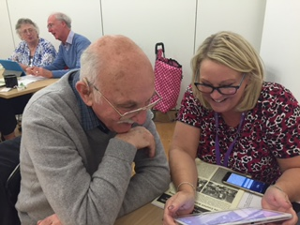
Doors open at 1.00pm and the talk or presentation begins at 1.30pm. A wide variety of issues are explored within this forum, followed by the opportunity for a chat.
The 2020 Programme is in development but please save these dates and feel free to contact Louise louisemcglen@deaflink.org.uk with ideas of what you would like covered
Tuesday 4th February Introductions and review (meet the new Involvement worker and a chance to talk about what you want from the group and have your say about content of meetings from May onwards)

Tuesday 3rd March Topic/ speaker TBC in January

Tuesday 7th April – Topic/ speaker TBC in January

If you would like to come along to our group please contact louisemcglen@deaflink.org.uk or call 0191 0191 281 2314

This project also offers the opportunity for anyone with a hearing loss to meet our project worker to discuss how our services might provide support. Our services include lip reading classes, monthly social, loop checking and challenging in addition to our monthly SHHH group.

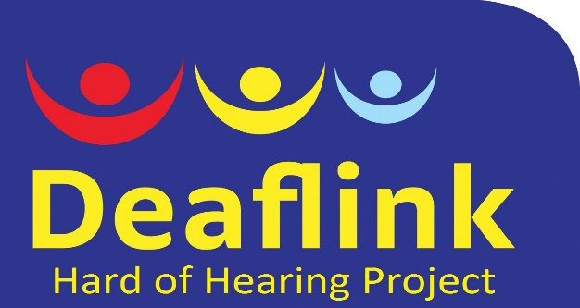
Deaflink North East is a Company Limited by Guarantee, registered in England and Wales; Company No. 7982375, Registered as Charity No. 1147237

